Our Corporate Pledge:
To provide the best value and service in building construction available
in the Mid-Coast area.
Year of Incorporation: 1968
Corporate Activity: Residential, Commercial, Steel Building Construction and Handyman Services
Number of Employees: 20-25
Annual Sales: $4,000,000 - $6,000,000

Management Team
Robert L. Davee | Owner | B.S.M.E University of Maine – 1959  Worcester Tech School of Industrial Management - 1969
John S. Davee  Team member  32 years | President  Commercial Division  Chief Executive Officer | B.S. Mechanical Engineering Technology –  Univ. of Maine - 1981  Business: 34 Years experience
Mark DeMichele  Team member  35 years | Senior Vice President  Chief Operating Officer  Residential Sales  Project Manager | B.A. American History/Education –  Seton Hall University - 1977  Business: 41 years experience
David P. Luckman  Team member  34 years | Vice President  Project Manager/CAD Design/Sales | Bristol - Plymouth Regional & Tech. High School - 1987  Business: 35 years’ experience
Paul Chamberlin  Team member  7 years | Chief Financial Officer | B.S. Business Administration – Univ. of Maine 1979  Business: 35 years experience
Randy Boyer  Team member  27 years | Project Manager  Steel | Apopka High School  Business: 28 years experience
Chris Ryan  Team member  21 years | Project Manager  Crew Manager | Business: 17 years experience
Chelsea Harrington Accounting Assistant B.S. Civil Engineering Univ. of Maine
5 years Business experience: 3 years

Notable Projects (*) indicates multiple projects or repeat customers

* | 449 Main Street, Rockland -Historic & Sustainable Renovation | 1 Million + | Historic Renovations
* | Friends of Rockland Breakwater Lighthouse
* | Pope Memorial Humane Society of Knox County – New | $ 1.8 Million + | Commercial
* | The Pitch – Indoor Soccer Facility | $ 2 Million | 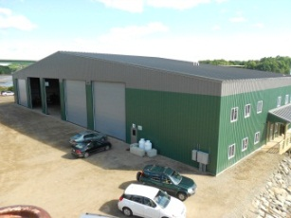  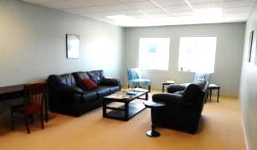
 | Swift Storage | $ 250 K
 | Jackson Memorial Library – Library Renovation | $ 1 Million
* | Front Street Shipyard – Multiple Steel Buildings & Renovations | $ 5 Million
* | Central Maine Cold Storage – Seafood Flash Freezer Building | $ 600K
 | Northeast Transport – Truck Maintenance Building | $ 300K
* | Journey’s End Marina/O’Hara Corp – Multiple Steel Buildings | $ 1-5 Million
* | Lyman Morse – Multiple Boat building and storage buildings | $ 1-5 Million
* | Coastal Opportunities – ADA compliant apartment building | $ 400K
* | Union Farm Equipment | $ 1 Million
* | Clark full house renovations – Camden | $ +/- 900K | Residential
* | Culver - Port Clyde historic cottage renovations | $ 100-200 K | 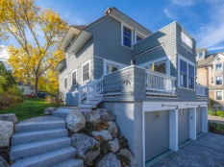  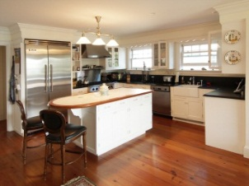
* | Fletcher – Full House Renovations - Rockport | $ +/- 1 M
* | O’Dell Renovations – Rockport | < 25 K
* | Holub House– St. George | $ +/- 600 K
 | Kibbe Custom Solar Powered Cape – Camden | $ +/- 550 K
 | Newbold - Solar Heated Super Insulated Cottage | $ +/- 400 K
* | Massimi – New cottage – Owl’s Head | $ +/- 250 K
* | Hammer/Crowe – New House - Camden | $ +/- 1 M
* | Porter New House- Rockport & Renovations Camden | $ +/- 1.5 M
* | Clayton – Kitchen Renovations | < $115K
* | Joffe-Tarkhanov – New House Camden | $ +/- 250 K

* Kupchunas – New House – Saint George, ME $ +/- 400 K
References

Bank Reference
Camden National Bank
PO Box 310
Camden ME 04843

Credit References
Hammond Lumber Co.  P O Box 5194  Ellsworth ME 04605-5194 | Blue Scope Building /Varco Pruden  3200 Players Club Circle  Memphis, TN 38125 | Viking Lumber  P.O. Box B  Belfast, ME 04915  (207) 338-3480
Residential Client References
Doug and Judy O’Dell  Rockport, ME 04856  Cg4meb@aol.com | Dr. David Kibbe  Camden, ME 04843  kibbedavid@mac.com | Jim Kinnealey & Cynthia Hyde  Taylor Hill Farm-Hope, Maine  hopefarm@midcoast.com
Dave Newbold  Camden, Maine  davenewbold@gmail.com | Peter J Fides  Newcastle, Maine  pfidesii@tidewater.net | Sheila and Tom Clark  Great Falls, VA  SAClark2@ aol.com
Bob Hammer  Rockport, ME 04851  rhammer@tidewater.net | Tom and Cindy Kupchunas  Saint George, ME 04860  tckup@yahoo.com | Joe & Donna Holub  Saint George, ME 04860  jholub@mail.com
Commercial Client References
Lyman Morse Boat Building  84 Knox Street  Thomaston, ME. 04861  cabot@lymanmorse.com  Mook Sea Farm  Bill Mook  321 State Route 129  Walpole, ME 04573  207-380-3274 | JB Turner  Front Street Shipyard  101 Front Street  Belfast, ME 04915  jb@frontstreetshipyard.com | Frank O’Hara Jr.  O’Hara Corporation  120 Tillson Avenue St.101  Rockland, ME 04841  (207) 594-4444
Professional References
Rockport Steel  17 Rockville Street  Rockport, ME 04856  terry@rockportsteel.com | Michael J Sabatini, P.E.  PO Box 929  23 Central Street, 2nd Fl  Rockport, ME 04856  msabatini@bpnmaine.com | Allen Insurance & Financial  34 Maine Street  Camden, ME 04843  (207) 236-4311

